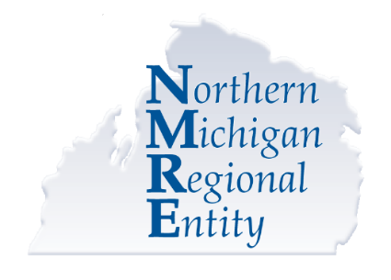
Opioid Health Home Program Enrollment Consent
www.nmre.org | 800-834-3393

Michigan Medicaid is launching a new service program to combat the opioid crisis. The program is available to individuals who have Medicaid, Healthy Michigan Plan, or MI Child, live in any of the 21-counties in the Northern Michigan Regional Entity service area, and have a qualifying health condition. The Michigan Department of Health and Human Services (MDHHS) recognizes that living with addiction or dependence and other health conditions is hard. The Opioid Health Home (OHH) Program is designed to help. You will be provided services as part of your Medicaid benefit that will help you take control of your health and have long-term recovery. By signing below, you agree to enroll in the OHH Program. You may also opt-out (disenroll) now, or at any time in the future, with no impact on your currently entitled Medicaid services.
The Opioid Health Home Program…
- Is not a place, but is a model of care that offers care coordination services
- Takes a holistic approach to your health care and provides you with one “home” base for coordinating your recovery and health needs
- Provides one-stop access to care to amplify your success and make it simpler and easier
- Coordinates your health, social, and recovery needs
- Assigns a personal care team to each enrolled individual
Your Care Team…
- Consists of a Nurse Care Manager, Clinical Case Manager, Recovery Coach or Community Health Worker, your Doctor, and YOU
- Works with other health care professionals you choose to coordinate your care
- Ensures you get the medical and mental health services you need to feel healthy and well
- Ensures you get the social services you need, such as food, transportation, and housing
- Provides individual and family support
- Assists you to get both your behavioral health and your physical health care needs met

Here’s what you should know…
- You still choose which health care providers will be involved in your care
- Your behavioral health and physical health services will be shared with other potential Health Home Partners through a secure system available only to those providing services
- These extra services will be provided with no cost to you; they are covered under your Medicaid plan
- You can opt out now, or at any time, and still have your Medicaid services unchanged
I acknowledge that I have been enrolled in the Opioid Health Home Program:
Signature: _____________________________________________________ Date: _______________
Printed Name: ______________________________________________________________________

