Process for obtaining verbal consents for Health Home Beneficiaries
January 2021
NMRE is permitting the use of verbal consents in the Health Home enrollment process on a limited basis, under the guidance of MDHHS and the Substance Abuse Services and Mental Health Administration (SAMHSA).

Per MDHHS, verbal consents are allowable in Health Home programs due to COVID and “if all other ways to obtain a signed consent are exhausted. The HHP who witnessed the verbal consent would sign the consent and identify it was a verbal consent.”

Within the Health Home Handbooks, section 4.3 BHH Service Encounter Codes for the Behavioral Health Home (BHH) program and section 4.4 OHH Service Encounter Coding Requirements for Opioid Health Home (OHH) program the requirement for the initial service of S0280 to be delivered in person has been modified for COVID. See information below;

- S0280
The initial service must be delivered in-person. (Note: Pursuant to state and federal policy related to the COVID-19 public health emergency, the initial service may be delivered in a non-face-to-face manner using the TS modifier. This flexibility will be effective with timelines cited in applicable state and federal policy commensurate with the public health emergency.)
When submitting a recommended enrollment for Health Home Services please include the full enrollment packet.
MDHHS 5515 – Please review form with client and fill out the form as you normally would with required information for client in sections 1 – 3.

If verbal consent is being obtained Section 4 of the MDHHS 5515 will be documented differently. Since there is not a spot on the form pertaining to verbal consents, please include the following;
- A verbal consent requires two signatures, one by the staff member obtaining the consent and one by a staff member who is witnessing the consent. Please print names and then sign and date in the required boxes. Indicate “verbal consent” in signature block.

- If you are able to type within either of the signature boxes on your electronic 5515 form, please document the reasons for the verbal consent, such as;
- Client unable to come into the office due to transportation
- Client unable to sign electronically in patient portal due to no internet connection
- Documents were mailed to client and they did not receive them or have not returned them to Health Home Provider

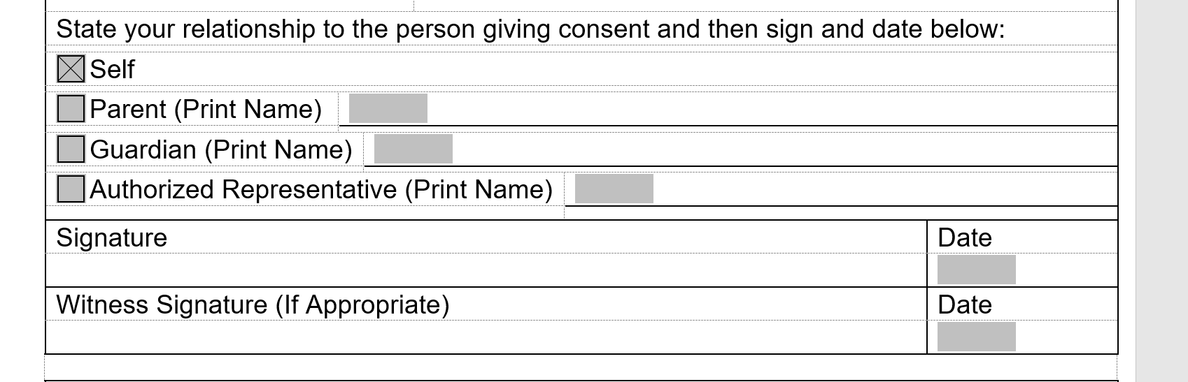
If you are unable to type the reasons within the 5515, please use a separate Microsoft document and attach to the enrollment packet.

Health Home Program Enrollment Consent
Please review this document with the client and explain the care coordination and services they can expect to receive as a participate in the Health Home program. Staff member should print, sign and date the form once this information has been reviewed with the client and indicate verbal consent was obtained.
A copy of the completed MDHHS 5515 and Health Home Enrollment consent forms should be mailed out to the client, along with any other related Health Home program materials.
The use of verbal consents for Health Home enrollments will be allowable for a period up to 90 days, extending through March 31, 2021 unless otherwise indicated by MDHHS or SAMHSA.

